**C# ASSIGNMENT 1**

Question 1

Write a C# Sharp program to accept a coordinate point in an XY coordinate system and determine in which quadrant the coordinate point lies.

// Driver code

class Program

{

public static void Main(string[] args)

{

Console.Write("Input the value for X coordinate :");

int x = Convert.ToInt32(Console.ReadLine());

Console.Write("Input the value for Y coordinate :");

int y = Convert.ToInt32(Console.ReadLine());

Class1 class1 = new Class1(x, y);

string result = class1.find_coordinates();

Console.WriteLine(result);

}

}

// Stub code

using System;

public class Class1

{

private int x; private int y;

public Class1(int x, int y)

{

this.X = x;

this.Y = y;

}

public int X { get => x; set => x = value; }

public int Y { get => y; set => y = value; }

public string find_coordinates()

{

if ((this.X > 0) && (this.Y>0))

{

return $"The coordinate point ({X},{Y}) lies in the First quadrant";

}

else if ((this.X < 0) && (this.Y > 0))

{

return $"The coordinate point ({X},{Y}) lies in the Second quadrant";

}

else if ((this.X < 0) && (this.Y < 0))

{

return $"The coordinate point ({X},{Y}) lies in the Third quadrant";

}

else if ((X > 0) && (Y < 0))

{

return $"The coordinate point ({X},{Y}) lies in the Fourth quadrant";

}

else

{

return $"The coordinate point ({X},{Y}) lies in the origin";

}

}

}

OUTPUT:

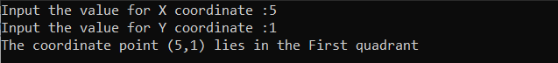

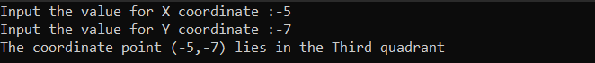

Question2

Write a C# Sharp program to read roll no, name and marks of three subjects and calculate the

total, percentage and division.

// Driver code

class Program

{

public static void Main(string[] args)

{

Console.Write("Input the Roll Number of the student :");

int roll_no = Convert.ToInt32(Console.ReadLine());

Console.Write("Input the Name of the Student :");

string name = Console.ReadLine();

Console.WriteLine("Input the marks of Physics, Chemistry and Computer Application :");

int physics = Convert.ToInt32(Console.ReadLine());

int chemistry = Convert.ToInt32(Console.ReadLine());

int comp = Convert.ToInt32(Console.ReadLine());

Class1 class1 = new Class1(roll_no, name, physics, chemistry, comp);

class1.calculate();

Console.WriteLine($"Roll No : {class1.Roll_no}");

Console.WriteLine($"Name of Student : {class1.Name}");

Console.WriteLine($"Marks in Physics : {class1.Physics}");

Console.WriteLine($"Marks in Chemistry : {class1.Chemistry}");

Console.WriteLine($"Marks in Computer Application : {class1.Comp}");

Console.WriteLine($"Total Marks = {class1.Total}");

Console.WriteLine($"Percentage = {class1.Percentage}");

Console.WriteLine($"Division = {class1.Divsion}");

}

}

// Stub code

using System;

using System.Xml.Linq;

public class Class1

{

private int roll_no; private string name; private int physics; private int chemistry; private int comp;

private int total; private double percentage; private string division;

public Class1(int roll_no, string name, int physics, int chemistry, int comp)

{

this.Roll_no = roll_no;

this.Name = name;

this.Physics = physics;

this.Chemistry = chemistry;

this.Comp = comp;

}

public int Roll_no { get => roll_no; set => roll_no = value; }

public string Name { get => name; set => name = value; }

public int Physics { get => physics; set => physics = value; }

public int Chemistry { get => chemistry; set => chemistry = value; }

public int Comp { get => comp; set => comp = value; }

public int Total { get => total; set => total = value; }

public double Percentage { get => percentage; set => percentage = value; }

public string Divsion { get => division; set => division = value; }

public void calculate()

{

this.Total = this.Physics + this.Chemistry + this.Comp;

this.Percentage = (double)this.Total / 3;

this.percentage = Math.Round(this.percentage, 2);

if (this.percentage>=80)

{

this.Divsion = "First";

}

else if ((this.percentage>=60) && (this.percentage<80))

{

this.Divsion = "Second";

}

else

{

this.Divsion = "Third";

}

}

}

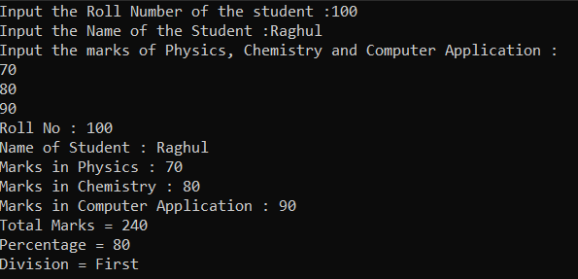

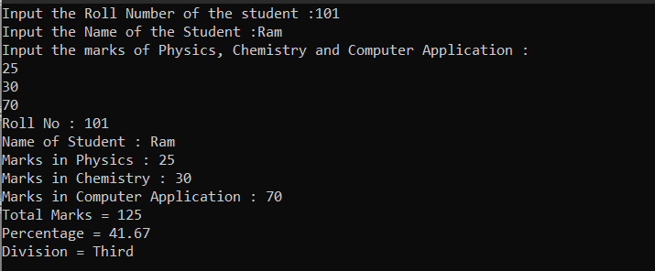

Question 3

Write a program in C# Sharp to calculate and print the Electricity bill of a given customer. The

customer id., name and unit consumed by the user should be taken from the keyboard and display

the total amount to pay to the customer.

// Driver code

class Program

{

public static void Main(string[] args)

{

Console.Write("Input the Customer ID :");

int cust_id = Convert.ToInt32(Console.ReadLine());

Console.Write("Input the Customer Name :");

string name = Console.ReadLine();

Console.WriteLine("Input the Units consumed:");

int units = Convert.ToInt32(Console.ReadLine());

Class1 class1 = new Class1(cust_id, name, units);

class1.calculate();

Console.WriteLine($"Customert ID : {class1.Cust_id}");

Console.WriteLine($"Customert Name : {class1.Name}");

Console.WriteLine($"Units Consumed : {class1.Units}");

Console.WriteLine($"Bill Amount Rs. {class1.Total_amt}");

}

}

// Stub code

using System;

using System.Xml.Linq;

public class Class1

{

private int cust_id; private string name; private int units;private double total_amt;

public Class1(int cust_id, string name, int units)

{

this.Cust_id = cust_id; ;

this.Name = name;

this.Units = units;

}

public int Cust_id { get => cust_id; set => cust_id = value; }

public string Name { get => name; set => name = value; }

public int Units { get => units; set => units = value; }

public double Total_amt { get => total_amt; set => total_amt = value; }

public void calculate()

{

if (this.Units <= 199)

{

this.Total_amt = Math.Round(1.20 * this.Units, 2);

}

else if ((this.Units>=200) && (this.Units<400))

{

this.Total_amt = Math.Round(1.50 * this.Units, 2);

}

else if ((this.Units >= 400) && (this.Units < 600))

{

this.Total_amt = Math.Round(1.80 * this.Units, 2);

}

else if (this.Units >= 600) {

this.Total_amt = Math.Round(2.00 * this.Units, 2);

}

if (this.Total_amt > 400)

{

this.Total_amt = this.total_amt * 1.15;

}

if (this.total_amt<100)

{

this.Total_amt = 100;

}

}

}

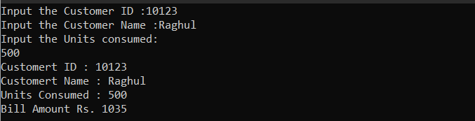

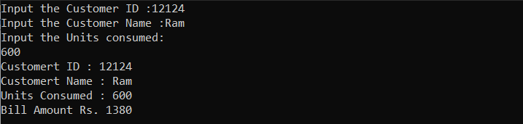

Question 4

Write a program in C# Sharp to make such a pattern like right angle triangle with number

increased by 1.

// Driver code

class Program

{

public static void Main(string[] args)

{

Class1 class1 = new Class1();

Console.WriteLine("Right angled triangle");

class1.right_triangle();

Console.WriteLine();

Console.WriteLine("Pyramid pattern");

class1.pyramid();

}

}

// Stub code

using System;

using System.Xml.Linq;

public class Class1

{

int count = 1;

public void right_triangle()

{

for (int i=1;i<=4;i++)

{

for(int j=1;j<=i;j++)

{

Console.Write(count + " ");

count += 1;

}

Console.WriteLine();

}

}

public void pyramid()

{

int rows = 4;

int num = 1;

for (int i = 1; i <= rows; i++)

{

for (int j = 1; j <= rows - i; j++)

{

Console.Write(" ");

}

for (int k = 1; k <= i; k++)

{

Console.Write(num.ToString().PadLeft(2) + " ");

num++;

}

Console.WriteLine();

}

Console.ReadLine();

}

}

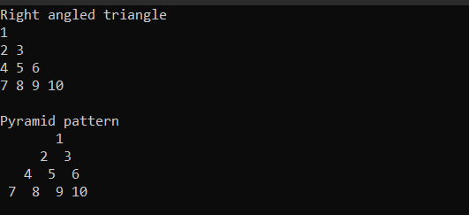

Question 5

Write a program in C# Sharp to

a. read n number of values in an array and display it in reverse order.

b. copy the elements one array into another array

c. find the sum of all elements of the array

d. count a total number of duplicate elements in an array.

e. print all unique elements in an array

f. find the second largest element in an array

// Driver code

class Program

{

public static void Main(string[] args)

{

Class1 class1 = new Class1();

class1.display_reverse();

class1.copy_elements();

class1.array_sum();

class1.duplicate_elements();

class1.unique_elements();

class1.second_large();

}

}

// Stub code

using System;

using System.Xml.Linq;

public class Class1

{

public void display_reverse()

{

Console.Write("Enter the number of values: ");

int n = int.Parse(Console.ReadLine());

int[] arr = new int[n];

Console.WriteLine("Enter the values:");

for (int i = 0; i < n; i++)

{

arr[i] = int.Parse(Console.ReadLine());

}

Console.WriteLine("Array in reverse order:");

for (int i = n - 1; i >= 0; i--)

{

Console.Write(arr[i] + " ");

}

Console.WriteLine();

}

public void copy_elements()

{

int[] arr1 = { 1, 2, 3, 4, 5 };

int[] arr2 = new int[arr1.Length];

for (int i = 0; i < arr1.Length; i++)

{

arr2[i] = arr1[i];

}

Console.WriteLine("Original Array:");

foreach (int num in arr1)

{

Console.Write(num + " ");

}

Console.WriteLine("\nConpied Array:");

foreach (int num in arr2)

{

Console.Write(num + " ");

}

Console.WriteLine();

}

public void array_sum()

{

int[] arr = { 1, 2, 3, 4, 5 };

int sum = 0;

foreach (int num in arr)

{

sum += num;

}

Console.WriteLine("Sum of all elements in the array: " + sum);

}

public void duplicate_elements()

{

int[] arr = { 1, 2, 2, 3, 4, 4, 5 };

int count = 0;

for (int i = 0; i < arr.Length; i++)

{

for (int j = i + 1; j < arr.Length; j++)

{

if (arr[i] == arr[j])

{

count++;

break;

}

}

}

Console.WriteLine("Total number of duplicate elements in the array: " + count);

}

public void unique_elements()

{

int[] arr = { 1, 2, 2, 3, 4, 4, 5 };

List<int> unique = new List<int>();

foreach (int num in arr)

{

if (!unique.Contains(num))

{

unique.Add(num);

}

}

Console.WriteLine("Unique elements in the array:");

foreach (int num in unique)

{

Console.Write(num + " ");

}

Console.WriteLine();

}

public void second_large()

{

int[] arr = { 1, 3, 2, 4, 5 };

int firstLargest = arr[0];

int secondLargest = arr[0];

for (int i = 1; i < arr.Length; i++)

{

if (arr[i] > firstLargest)

{

secondLargest = firstLargest;

firstLargest = arr[i];

}

else if (arr[i] > secondLargest && arr[i] != firstLargest)

{

secondLargest = arr[i];

}

}

Console.WriteLine("Second largest element in the array: " + secondLargest);

}

}

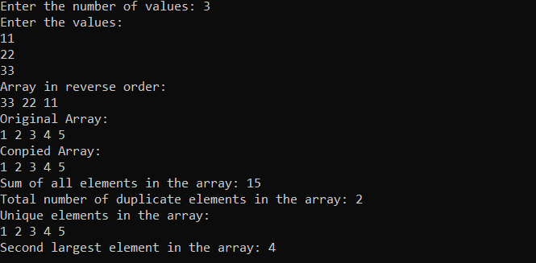

Question 6

Write a program in C# Sharp to find transpose of a given matrix.

// Driver code

class Program

{

public static void Main(string[] args)

{

Class1 class1 = new Class1();

class1.matrix_transpose();

}

}

// Stub code

using System;

using System.ComponentModel;

using System.Xml.Linq;

public class Class1

{

public void matrix_transpose()

{

int[,] matrix = {{1, 2, 3},

{4, 5, 6},

{7, 8, 9}};

int rows = matrix.GetLength(0);

int cols = matrix.GetLength(1);

int[,] transpose = new int[cols, rows];

for (int i = 0; i < rows; i++)

{

for (int j = 0; j < cols; j++)

{

transpose[j, i] = matrix[i, j];

}

}

Console.WriteLine("Original matrix:");

for (int i = 0; i < rows; i++)

{

for (int j = 0; j < cols; j++)

{

Console.Write(matrix[i, j] + " ");

}

Console.WriteLine();

}

Console.WriteLine("Transpose of the matrix:");

for (int i = 0; i < cols; i++)

{

for (int j = 0; j < rows; j++)

{

Console.Write(transpose[i, j] + " ");

}

Console.WriteLine();

}

}

}

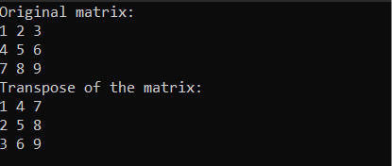

Question 7

Write a C# Sharp program that calculates the sum of all prime numbers in an array of numbers

using System;

class Program

{

static bool IsPrime(int number)

{

if (number < 2)

return false;

for (int i = 2; i <= Math.Sqrt(number); i++)

{

if (number % i == 0)

return false;

}

return true;

}

static void Main(string[] args)

{

int[] numbers = { 1, 2, 3, 4, 5, 6, 7, 8, 9, 10 };

int sum = 0;

foreach (int number in numbers)

{

if (IsPrime(number))

sum += number;

}

Console.WriteLine("The sum of prime numbers in the array is: {0}", sum);

}

}



Question 8

Write a program in C# Sharp to count the total number of words in a string.

using System;

class Program

{

static void Main(string[] args)

{

Console.Write("Enter a string: ");

string input = Console.ReadLine();

int wordCount = 0;

string[] words = input.Split(new[] { ' ', '\t', '\r', '\n' }, StringSplitOptions.RemoveEmptyEntries);

wordCount = words.Length;

Console.WriteLine("Total number of words in the string: {0}", wordCount);

}

}



Question 9

Write a program in C# Sharp to count a total number of alphabets, digits and special characters in

a string.

using System;

class Program

{

static void Main(string[] args)

{

Console.Write("Enter a string: ");

string input = Console.ReadLine();

int alphabets = 0;

int digits = 0;

int specialChars = 0;

// Loop through each character in the input string

foreach (char c in input)

{

if (Char.IsLetter(c))

{

alphabets++;

}

else if (Char.IsDigit(c))

{

digits++;

}

else

{

specialChars++;

}

}

Console.WriteLine("Total number of alphabets in the string: {0}", alphabets);

Console.WriteLine("Total number of digits in the string: {0}", digits);

Console.WriteLine("Total number of special characters in the string: {0}", specialChars);

}

}

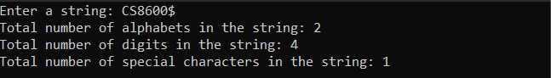

Question 10

Write a C# Sharp program to find the middle character(s) of a given string. Return the middle

character if the length of the string is odd and return two middle characters if the length of the

string is even.

using System;

class Program

{

static void Main(string[] args)

{

Console.Write("Enter a string: ");

string input = Console.ReadLine();

string middleChars = GetMiddleChars(input);

Console.WriteLine("Middle character(s): {0}", middleChars);

}

static string GetMiddleChars(string input)

{

int length = input.Length;

int mid = length / 2;

if (length % 2 == 0)

{

return input.Substring(mid - 1, 2);

}

else

{

return input.Substring(mid, 1);

}

}

}





Question 11

Write a program in C# Sharp to create a function to display the n number Fibonacci sequence.

using System;

class Program

{

static void Main(string[] args)

{

Console.Write("Enter the number of terms in the Fibonacci sequence: ");

int n = int.Parse(Console.ReadLine());

Console.WriteLine("Fibonacci sequence:");

for (int i = 0; i < n; i++)

{

Console.Write("{0} ", Fibonacci(i));

}

}

static int Fibonacci(int n)

{

if (n == 0 || n == 1)

{

return n;

}

else

{

return Fibonacci(n - 1) + Fibonacci(n - 2);

}

}

}



Question 12

Write a program in C# Sharp to create a function to check if a given number is Armstrong number

or not

using System;

class Program

{

static bool IsArmstrong(int num)

{

int sum = 0;

int temp = num;

int digits = num.ToString().Length;

while (temp != 0)

{

int digit = temp % 10;

sum += (int)Math.Pow(digit, digits);

temp /= 10;

}

return sum == num;

}

static void Main(string[] args)

{

Console.WriteLine("Enter a number");

int num = Convert.ToInt32(Console.ReadLine());

if (IsArmstrong(num))

{

Console.WriteLine(num + " is an Armstrong number");

}

else

{

Console.WriteLine(num + " is not an Armstrong number");

}

}

}

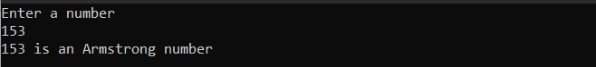

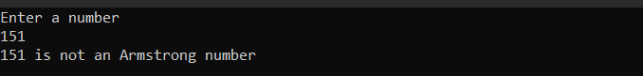

Question 13

Write a program in C# Sharp to create a function to check if a given number is Perfect number or

not

using System;

class Program

{

static void Main(string[] args)

{

Console.Write("Enter a positive integer: ");

int n = int.Parse(Console.ReadLine());

if (IsPerfect(n))

{

Console.WriteLine("{0} is a perfect number.", n);

}

else

{

Console.WriteLine("{0} is not a perfect number.", n);

}

}

static bool IsPerfect(int n)

{

int sum = 0;

// Check each divisor up to n/2

for (int i = 1; i <= n / 2; i++)

{

if (n % i == 0)

{

sum += i;

}

}

return sum == n;

}

}





Question 14

Write a program in C# Sharp to create a function to check if a given number is Prime number or

not

using System;

class Program

{

static void Main(string[] args)

{

Console.Write("Enter a positive integer: ");

int n = int.Parse(Console.ReadLine());

if (IsPrime(n))

{

Console.WriteLine("{0} is a prime number.", n);

}

else

{

Console.WriteLine("{0} is not a prime number.", n);

}

}

static bool IsPrime(int n)

{

if (n <= 1)

{

return false;

}

for (int i = 2; i <= Math.Sqrt(n); i++)

{

if (n % i == 0)

{

return false;

}

}

return true;

}

}





Question 15

Write a program in C# Sharp to

a. create a function to check if a given string is Palindrome or not

b. create a function to check if a given number is Palindrome or not

using System;

class Program

{

static void Main(string[] args)

{

// Check if a string is a palindrome

Console.Write("Enter a string: ");

string str = Console.ReadLine();

if (IsPalindrome(str))

{

Console.WriteLine("{0} is a palindrome.", str);

}

else

{

Console.WriteLine("{0} is not a palindrome.", str);

}

// Check if a number is a palindrome

Console.Write("Enter a positive integer: ");

int n = int.Parse(Console.ReadLine());

if (IsPalindrome(n))

{

Console.WriteLine("{0} is a palindrome.", n);

}

else

{

Console.WriteLine("{0} is not a palindrome.", n);

}

}

// Function to check if a string is a palindrome

static bool IsPalindrome(string str)

{

int i = 0;

int j = str.Length - 1;

while (i < j)

{

if (str[i] != str[j])

{

return false;

}

i++;

j--;

}

return true;

}

// Function to check if a number is a palindrome

static bool IsPalindrome(int n)

{

int temp = n;

int reverse = 0;

while (temp > 0)

{

int digit = temp % 10;

reverse = reverse * 10 + digit;

temp /= 10;

}

return n == reverse;

}

}

